Question Scheme Marks
number

1. (a) 2+1-5 + c = 0 or -2 + c = 0 M1

c = 2 A1 (2)

(b) f(x) = 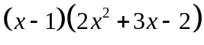 (x – 1) B1

division M1

= … 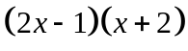 M1 A1 (4)

(c) f 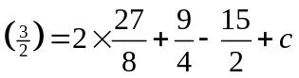 M1

Remainder = c + 1.5 = 3.5 ft their c A1ft (2)

Total 8 marks

2. (a) 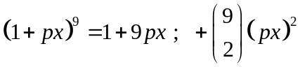 B1 B1 (2)
(b) 9p = 36, so p = 4 M1 A1

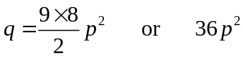 or 36p if that follows from their (a) M1

So q = 576 A1cao (4)

Total 6 marks
3. (a) 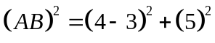 [= 26] M1

AB = 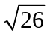 A1 (2) (b) 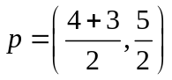 M1

= 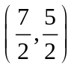 A1 (2)

(c) 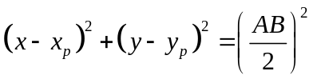 LHS M1 RHS M1

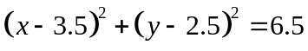 oe A1 c.a.o (3)

Total 7 marks

Question Scheme Marks
number

4. (a) 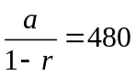 M1

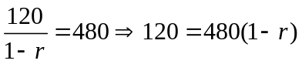 M1

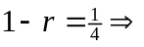 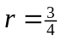 * A1cso (3)

(b) 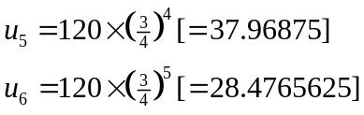 either M1

Difference = 9.49 (allow ) A1 (2)

(c) 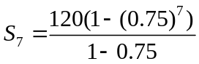 M1

= 415.9277… (AWRT) 416 A1 (2) (d) 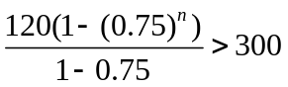 M1

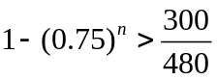 (or better) A1

n > 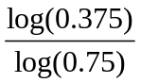 (=3.409…) M1

n = 4 A1cso (4)

Total 11 marks

5. (a) 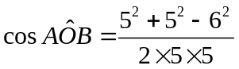 or M1

= 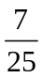 * A1cso (2)

(b) 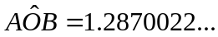 radians 1.287 or better B1 (1)

(c) Sector = 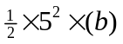, = 16.087… (AWRT) 16.1 M1 A1 (2)

(d) Triangle = 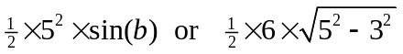 M1

Segment = (their sector) – their triangle dM1

= (sector from c) – 12 = (AWRT)4.1 (ft their part(c)) A1ft (3)

Total 8 marks

Question Scheme Marks
number

6. (a) t = 15 25 30

v = 3.80 9.72 15.37 B1 B1 B1 (3)

(b) B1 [M1] = 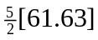 = 154.075 = AWRT 154 A1 (3)

Total 6 marks

7. (a) 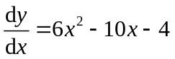 M1 A1 (2)

(b) 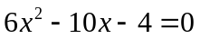 M1

2(3x + 1) 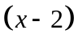 [=0] M1 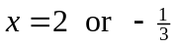 (both x values) A1

Points are (2, - 10) and 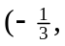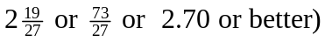 (both y values) A1 (4)

(c) 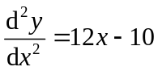 M1 A1 (2)

(d) 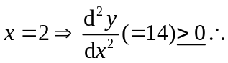[(2, - 10)] is a Min M1

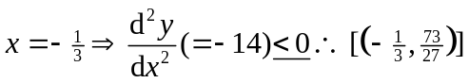 is a Max A1 (2)

Total 10 marks

Question Scheme Marks
number

8. (a) 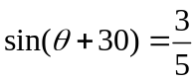 ( on RHS) B1

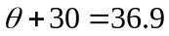 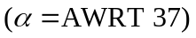 B1

or = 143.1 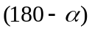 M1

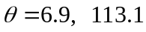 A1cao (4)

(b) 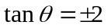 or 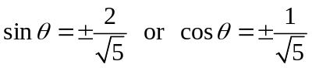 B1

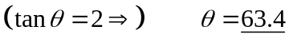 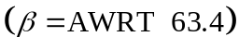 B1

or 243.4 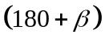 M1

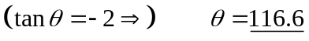 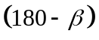 M1

or 296.6 (180 + their 116.6) M1 (5)

Total 9 marks

Question Scheme Marks
number

9. (a) 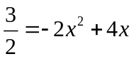 M1

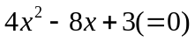 A1

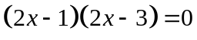 M1

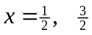 A1 (4)

(b) Area of R = 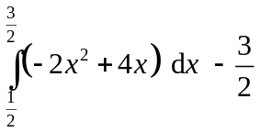 (for 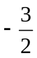) B1

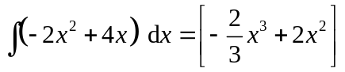 (Allow 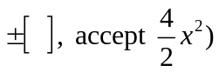 M1 [A1]

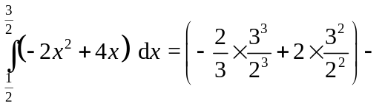, 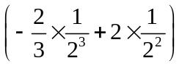 M1 M1

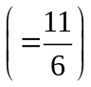

Area of R = 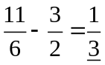 (Accept exact equivalent but not 0.33…) A1cao (6)

Total 10 marks

